FreeWill + American Diabetes Association: 3-part email series
August 2025 Make-A-Will Month Bequest Campaign - Donors

Please use the Tracking Links that accompany this email series so we can accurately track gifts generated from this outreach.

Initial Email---- August 1st
**Bequest Tracking Link for Initial Email (please hyperlink to this URL as demonstrated below):
https://www.freewill.com/diabetes?utm_source=partner&utm_medium=eblast&utm_campaign=202508_diabetes_mawm_soft_impact_donors
**Gift Intent Form Tracking Link for Initial Email (please hyperlink to this URL as demonstrated below):
https://www.freewill.com/record/diabetes?utm_source=partner&utm_medium=eblast&utm_campaign=202508_diabetes_mawm_soft_impact_donors_ps
—
Subject line options:
- In a world of unknowns, be the sunshine

Preview Text: National Make-A-Will Month is the perfect time to protect what matters most.
Body: 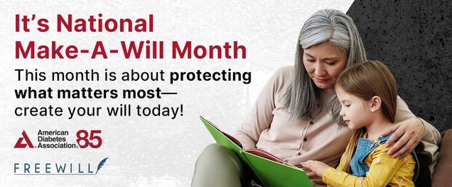
August brings sunny skies and joyful moments, but it also offers a powerful reminder: It’s National Make-A-Will Month, a time to shine a light on the future and the people you love.
Creating a will is a meaningful way to bring clarity, comfort, and peace of mind to those around you. That is why the American Diabetes Association® has partnered with Freewill to offer our supporters a secure, easy, and completely free tool that helps you create or update your will.
Having a will means that you:
☀️ Protect your family’s future
☀️ Clearly share your wishes
☀️ Support the causes close to your heart
Create My Free Will

This August, be the sunshine. Light the way for your loved ones—and create a plan of care and purpose.
Have you already included a gift to the American Diabetes Association in your will? Please let us know so we can thank you for your incredible commitment in the fight to end diabetes.

Second Email---August 13th

Follow-Up Email
**Bequest Tracking Link for Follow-Up Email (please hyperlink to this URL as demonstrated below):
https://www.freewill.com/diabetes?utm_source=partner&utm_medium=followup&utm_campaign=202508_diabetes_mawm_soft_impact_donors
**Gift Intent Form Tracking Link for Follow-Up Email (please hyperlink to this URL as demonstrated below):
https://www.freewill.com/record/diabetes?utm_source=partner&utm_medium=followup&utm_campaign=202508_diabetes_mawm_soft_impact_donors_ps Subject line:
- From Dr. Baker’s lab to your inbox

Preview Text: Learn how you can support research through your planning

Body:
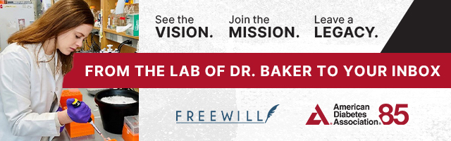
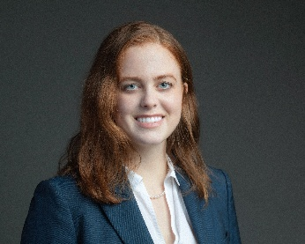
“Because of your enduring commitment to the American Diabetes Association, I’m able to pursue innovative research that is shaping the future of diabetes care. Your foresight and generosity are helping to unlock new treatments and bring hope to millions. Thank you for investing in a healthier tomorrow.”
— Dr. Megan Baker, Yale University
Earlier this year, we had the opportunity to visit Yale University and tour the lab of Dr. Megan Baker—a dedicated physician and groundbreaking researcher whose work is made possible by the ADA and supporters like you.
August is National Make-A-Will Month—a meaningful time to think about the future you want to shape. If you haven’t yet created your will, there’s still time to do it with FreeWill.com—a secure, no-cost resource trusted by many in the ADA community. It is a powerful way to care for your loved ones while supporting the causes that matter most to you.
Make Your Will Today!

If you already have a will that includes a gift to the ADA, please let us know so we can thank you for your generosity. If you have any questions contact Sue or Chelsy on our Planned Giving team by email.

Third Email---August 26th
**Bequest Tracking Link for Email (please hyperlink to this URL as demonstrated below):
https://www.freewill.com/diabetes?utm_source=partner&utm_medium=followup&utm_campaign=202508_diabetes_mawm_noask_story
**Gift Intent Form Tracking Link for Email (please hyperlink to this URL as demonstrated below):
https://www.freewill.com/record/diabetes?utm_source=partner&utm_medium=followup&utm_campaign=202508_diabetes_mawm_noask_story_ps

Subject line:
- A personal message from our CEO
Preview Text: Learn how supporters like Lori are empowering the future.
“Leaving a gift for the American Diabetes Association in my estate plan was never in question. I hope that my gift will help prevent individuals with diabetes from coming anywhere near the 47 years I’ve lived with the disease. At the very least, I know it will help ensure that the ADA continues to be there for those that need their support—until the joyous day that a cure is found.” – Lori, Camille Circle Member and Freewill customer
Dear [First Name],
This August, in recognition of National Make-A-Will Month, I want to personally invite you to reflect on the legacy you want to leave. Creating a will is a powerful way to care for your loved ones—and to support the causes that have shaped your life. That’s why we’ve partnered with FreeWill, a secure and free tool that allows you to create or update your long-range plans.
Start My Will

If the ADA’s work has touched your life, I hope you’ll consider joining supporters like Lori—who has lived with diabetes for nearly five decades and made the extraordinary decision to include the ADA in her estate plan.
With gratitude,
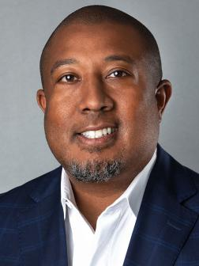
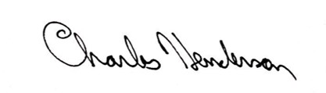
Charles “Chuck” Henderson
Chief Executive Officer
American Diabetes Association

P.S. If you already have a will that includes a gift to the ADA, please let us know so we can thank you for your generosity. If you have any questions, contact Sue or Chelsy on our Planned Giving team by email.

